Theory of Computation

Practical 1

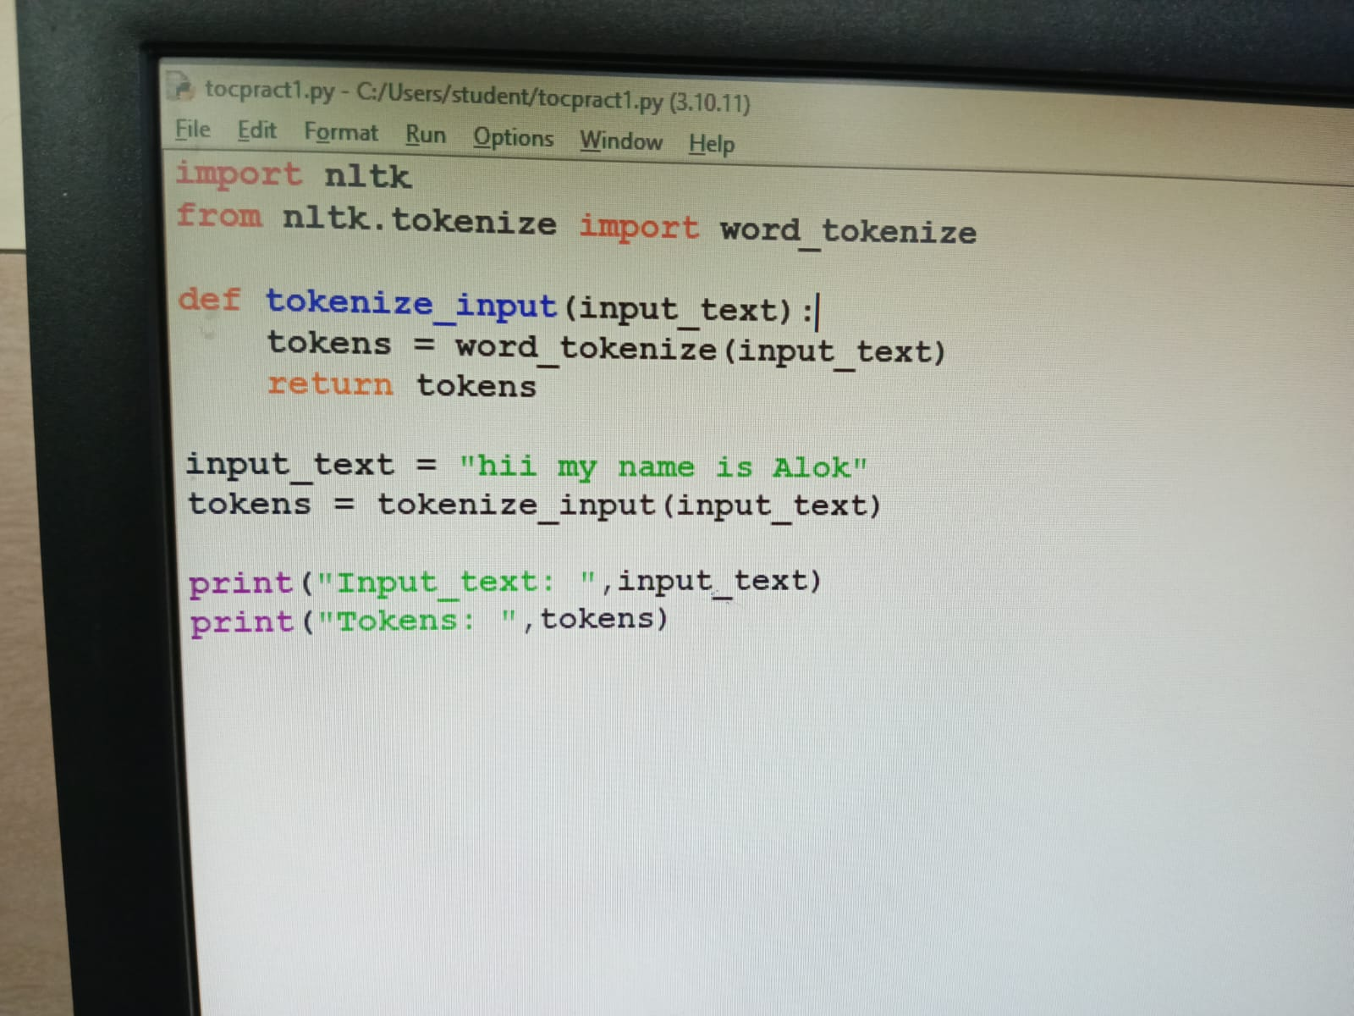

exp 2 :

import re

def generate_regex_from_grammar(grammar):

regex_dict = {}

for rule in grammar:

non_terminal, production = rule.split(' -> ')

if non_terminal not in regex_dict:

regex_dict[non_terminal] = set()

for symbol in production.split('|'):

# Handle terminals (characters)

if symbol.isalpha() and len(symbol) == 1:

regex_dict[non_terminal].add(re.escape(symbol))

# Handle non-terminals

else:

regex_dict[non_terminal].add(symbol)

# Convert the sets to regular expressions

for non_terminal, expressions in regex_dict.items():

regex_dict[non_terminal] = '|'.join(expressions)

return regex_dict

# Example usage:

grammar = [

"S -> aA|bB",

"A -> a|cA",

"B -> b|d"

]

regex_dict = generate_regex_from_grammar(grammar)

# Output the generated regular expressions

for non_terminal, regex in regex_dict.items():

print(f"{non_terminal} -> {regex}")

exp 3 :

def generate_derivation(grammar, start_symbol, sequence, max_depth=10):

derivation_sequences = []

def derive(current_sequence, depth):

if depth == 0:

return

for rule in grammar:

non_terminal, production = rule.split(' -> ')

alternatives = production.split('|')

for alt in alternatives:

if current_sequence.startswith(alt):

new_sequence = current_sequence.replace(alt, non_terminal, 1)

derivation_sequences.append(new_sequence)

derive(new_sequence, depth - 1)

derive(sequence, max_depth)

return derivation_sequences

# Example usage:

grammar = [

"S -> AB",

"A -> a|ε",

"B -> b"

]

start_symbol = 'S'

target_sequence = 'ab'

derivation_sequences = generate_derivation(grammar, start_symbol, target_sequence)

# Output the generated derivation sequences

for i, deriv_seq in enumerate(derivation_sequences, 1):

print(f"Derivation Sequence {i}: {deriv_seq}")

exp 4 :

def accepts_three_consecutive_ones(input_str):

current_state = 'q0'

for symbol in input_str:

if current_state == 'q0' and symbol == '1':

current_state = 'q1'

elif current_state == 'q1' and symbol == '1':

current_state = 'q2'

elif current_state == 'q2' and symbol == '1':

return True

else:

current_state = 'q0'

return False

# Example usage:

input_str = input("Enter a binary string: ")

result = accepts_three_consecutive_ones(input_str)

if result:

print("Accepted: The string contains three consecutive '1's.")

else:

print("Rejected: The string does not contain three consecutive '1's.")

exp5 :

def accepts_string_ending_with_101(input_str):

current_state = 'q0'

for symbol in input_str:

if current_state == 'q0' and symbol == '1':

current_state = 'q1'

elif current_state == 'q1' and symbol == '0':

current_state = 'q2'

elif current_state == 'q2' and symbol == '1':

current_state = 'q3'

else:

current_state = 'q0'

return current_state == 'q3'

# Example usage:

input_str = input("Enter a binary string: ")

result = accepts_string_ending_with_101(input_str)

if result:

print("Accepted: The string ends with '101'.")

else:

print("Rejected: The string does not end with '101'.")

exp 6 :

def is_divisible_by_2(input_str):

current_state = 'q0'

for digit in input_str:

if current_state == 'q0' and digit in '02468':

current_state = 'q1'

elif current_state == 'q1' and digit in '02468':

current_state = 'q0'

else:

return False

return current_state == 'q0'

# Example usage:

input_str = input("Enter a decimal number: ")

# Check if the entered number is divisible by 2

result = is_divisible_by_2(input_str)

if result:

print("Accepted: The decimal number is divisible by 2.")

else:

print("Rejected: The decimal number is not divisible by 2.")

exp 7 :

def accepts_equal_01(input_str):

count_1 = 0

count_0 = 0

for symbol in input_str:

if symbol == '1':

count_1 += 1

elif symbol == '0':

count_0 += 1

return count_1 == count_0

# Example usage:

input_str = input("Enter a binary string: ")

result = accepts_equal_01(input_str)

if result:

print("Accepted: The string has an equal number of '1's and '0's.")

else:

print("Rejected: The string does not have an equal number of '1's and '0's.")

exp 8 :

def count_ones_and_zeros(input_str):

count_1 = 0

count_0 = 0

for symbol in input_str:

if symbol == '1':

count_1 += 1

elif symbol == '0':

count_0 += 1

return count_1, count_0

# Example usage:

input_str = input("Enter a binary string: ")

count_1, count_0 = count_ones_and_zeros(input_str)

print(f"Number of '1's: {count_1}")

print(f"Number of '0's: {count_0}")

exp 9 :

from pyformlang.pda import State, PDA, Symbol, StackSymbol

def create_wcwr_pda():

# Define states

q0 = State("q0")

q1 = State("q1")

q_accept = State("q_accept")

q_reject = State("q_reject")

# Define stack symbols

sigma = set([Symbol("0"), Symbol("1"), Symbol("c")])

gamma = set([StackSymbol("Z")])

# Define transitions

transitions = [

((q0, Symbol("0"), StackSymbol("Z")), (q0, [StackSymbol("0"), StackSymbol("Z")])),

((q0, Symbol("1"), StackSymbol("Z")), (q0, [StackSymbol("1"), StackSymbol("Z")])),

((q0, Symbol("0"), StackSymbol("0")), (q0, [StackSymbol("0"), StackSymbol("0")])),

((q0, Symbol("1"), StackSymbol("1")), (q0, [StackSymbol("1"), StackSymbol("1")])),

((q0, Symbol("c"), StackSymbol("0")), (q1, [])),

((q1, Symbol("0"), StackSymbol("0")), (q1, [])),

((q1, Symbol("1"), StackSymbol("1")), (q1, [])),

((q1, Symbol(""), StackSymbol("Z")), (q_accept, [])),

((q0, Symbol(""), StackSymbol("Z")), (q_reject, [])),

]

pda = PDA(

states={q0, q1, q_accept, q_reject},

input_symbols=sigma,

stack_symbols=gamma,

transitions=transitions,

initial_state=q0,

initial_stack_symbol=StackSymbol("Z"),

final_states={q_accept},

)

return pda

def test_wcwr_pda(input_str):

pda = create_wcwr_pda()

result = pda.accepts_input(list(input_str))

return result

# Example usage:

input_str = input("Enter a string: ")

result = test_wcwr_pda(input_str)

if result:

print("Accepted: The string is in the language WCWR.")

else:

print("Rejected: The string is not in the language WCWR.")